GREEN CAMPUS PERFOMANCE
DASHBOARD
PROJECT REPORT
Submitted by
VISHWA S (7376232IT280)

In partial fulfilment for the award of the degree of

BACHELOR OF TECHNOLOGY
in

INFORMATION TECHNOLOGY

BANNARI AMMAN INSTITUTE OF TECHNOLOGY
(An Autonomous Institution Affiliated to Anna University, Chennai) SATHYAMANGALAM-638401

ANNA UNIVERSITY: CHENNAI 600 025

OCTOBER 2023

BONAFIDE CERTIFICATE

Certified that this project report “GREEN CAMPUS PERFORMACE DASHBOARD” is the Bonafide work of "VISHWA S (7376232IT280)" who carried out the project work under my supervision.

Dr. Naveena S, Prof. Chozharajan P,

HEAD OF THE DEPARTMENT ASSISTANT PROFESSOR - III

Department of Information Technology
Department of Artificial Intelligence and Data Science

Bannari Amman Institute of Technology Bannari Amman Institute of Technology

Submitted for Project Viva Voice examination held on………………

Internal Examiner 1 Internal Examiner 2

DECLARATION

We affirm that the project work titled “GREEN CAMPUS PERFORMANCE DASHBOARD” being submitted in partial fulfilment for the award of the degree of Bachelor of Technology in Information Technology is the record of original work done by us under the guidance of Prof. Chozharajan P, Assistant Professor, Department of Artificial Intelligence and Data Science. It has not formed a part of any other project work(s) submitted for the award of any degree or diploma, either in this or any other University.

(Signature of candidate)
VISHWA S
(7376232IT280)

I certify that the declaration made above by the candidates is true.

(Signature of the Guide)

Prof. Chozharajan P

ACKNOWLEDGEMENT

We would like to enunciate heartfelt thanks to our esteemed and visionary Chairman Dr. S.V. Balasubramaniam, and the respected Principal Dr. C. Palanisamy for providing excellent facilities and support during the course of study in this institute.

We are grateful to Dr. Naveena S, Head of the Department, Department of Information Technology for her valuable suggestions to carry out the project work successfully.
We wish to express our sincere thanks to Faculty guide Prof. Chozharajan P, Assistant Professor - III, Department of Artificial Intelligence and Data Science, for his constructive ideas, inspirations, encouragement, excellent guidance, and much needed technical support extended to complete our project work.

We would like to thank our friends, faculty and non-teaching staff who have directly and indirectly contributed to the success of this project.

VISHWA S (7376232IT280)

ABSTRACT
GREEN CAMPUS PERFORMACE DASHBOARD

The Green Campus Performance Dashboard is a web-based application developed to monitor, analyze, and improve environmental sustainability within a campus. The system provides a centralized platform to track key ecological parameters such as energy consumption, water usage, waste management, and carbon emissions. It features two types of users: Admin and User. The Admin dashboard enables full control over data management, including adding, editing, and deleting weekly records, while also providing a comprehensive monthly overview through visualizations like bar charts and pie charts. The system also generates a Green Score based on the collected data, which reflects the overall environmental performance of the campus.
The User dashboard allows users to view all environmental metrics and trends without modification privileges, ensuring transparency and awareness. Additionally, a communication module is included through a Contact Us feature, enabling users to send queries and receive responses from the Admin. The application is developed using React.js for the frontend, Python for backend processing, and MongoDB for data storage. This project aims to promote sustainable practices by providing actionable insights and encouraging data-driven decision-making in campus management.

Keywords:
Green Campus, Sustainability, Dashboard, Environmental Monitoring, Energy Consumption, Water Usage, Waste Management, Carbon Emissions, Green Score, Data Visualization, React.js, Python, MongoDB

TABLE OF CONTENT

Chapter No Title Page No

Acknowledgement

Abstract 1
Table of contents 2
List of tables 6
List of figures 7
1 INTRODUCTION 8
  - BACKGROUND AND CONTEXT 8
  - PROBLEM STATEMENT 9
  - OBJECTIVES OF THE PROJECT 9
  - SIGNIFICANCE OF THE STUDY 10
  - RELEVANCE IN THE CURRENT 11
TECHNOLOGICAL LANDSCAPE
    - LITERATURE SURVEY 13
      - INTRODUCTION 13
      - TRADITIONAL DOCUMENTATION 14
TECHNIQUES
      - DIGITAL ENVIRONMENT MONITORING 15
SYSTEMS
      - DATA VISUALIZATION TECHNIQUES 16
      - ROLE BASED ACCESS CONTROL 17
SYSTEMS

      - SUSTAINABILITY METRICS AND SCORING 18
SYSTEMS
      - SMART CAMPUS TECHNOLOGIES 19
      - WEB-BASED DASHBOARD SYSTEMS 19
      - NoSQL DATABASES IN ENVIRONMENTAL 20
SYSTEMS
2.10 DECISION SUPPORT SYSTEMS 21
2.11 ROLE OF DATA ANALYTICS IN SUSTAINABILITY 21
2.12 ENVIRONMENTAL MONITORING SYSTEMS 22
2.13 HUMAN-COMPUTER INTERACTION IN 22
DASHBOARD DESIGN
2.14 CLOUD-BASED SYSTEMS IN MONITORING 23
APPLICATIONS
2.15 IMPORTANCE OF SUSTAINABILITY IN 23
CAMPUS MANAGEMENT
    - OBJECTIVES 25
      - INTRODUCTION 25
      - CENTRALIZED MONITORING OBJECTIVE 25
      - DATA VISUALIZATION OBJECTIVE 26
      - DATA MANAGEMENT OBJECTIVE 27
      - SUSTAINABILITY EVALUATION OBJECTIVE 27
      - USER INTERACTION OBJECTIVE 28
      - SECURITY AND ACCESS CONTROL OBJECTIVE 28
      - PERFORMANCE AND SCALABILITY OBJECTIVE 29
      - ALERT AND NOTIFICATION OBJECTIVE 29
      - COMPARATIVE ANALYSIS OBJECTIVE 30
      - MODULAR DESIGN OBJECTIVE 30
      - DATABASE MANAGEMENT OBJECTIVE 31
      - USER EXPERIENCE OBJECTIVE 31
      - OBJECTIVES SUMMARY TABLE 32
    - PROPOSED WORK MODULES 33
      - INTRODUCTION 33
      - OVERALL DASHBOARD MODULE 34
      - ENERGY MANAGEMENT MODULE 34
      - WATER MANAGEMENT MODULE 35
      - WASTE MANAGEMENT MODULE 35
      - CARBON EMISSION MODULE 35
      - GREEN SCORE MODULE 36
      - USER MANAGEMENT MODULE 36
      - COMMUNICATION MODULE 37
    - RESULTS AND DISCUSSION 38
      - INTRODUCTION 38
      - OVERALL SYSTEM PERFORMANCE 38
      - DASHBOARD OUTPUT ANALYSIS 39
      - PARAMETER-WISE PERFORMANCE ANALYSIS 39
      - GREEN SCORE EVALUATION 39
      - USER INTERACTION AND FEEDBACK 40
      - ADVANTAGES OF THE SYSTEM 40
      - LIMITATIONS AND FUTURE IMPROVEMENTS 40
    - CONCLUSIONS & SUGGESTIONS FOR FUTURE 41
WORK
      - CONCLUSION 41
      - SUGGESTIONS FOR FUTURE WORK 42
REFERENCES 44
APPENDICES 46

LIST OF TABLES

Table No Table Page No
Table 3.1 OBJECTIVES SUMMARY TABLE 32

LIST OF FIGURES

Figure No | Figures | Page No
Figure 1 | FRONTEND INTERFACE | 46
Figure 2 | BACKEND IMPLEMENTATION | 47
Figure 3 | OVERALL DASHBOARD | 48
Figure 4 | ENERGY DASHBOARD | 49
Figure 5 | WATER DASHBOARD | 50

CHAPTER I INTRODUCTION

BACKGROUND AND CONTEXT
In recent years, environmental sustainability has become an important focus for educational institutions, particularly campuses that consume large amounts of energy, water, and other natural resources while also generating waste and carbon emissions. As awareness of climate change increases, there is a growing need for effective systems that can monitor and manage these environmental factors. However, many campuses still rely on manual or fragmented methods of data collection, which makes it difficult to track performance, identify inefficiencies, and implement sustainable practices.
To overcome these challenges, the Green Campus Performance Dashboard is developed as a centralized digital platform that integrates multiple environmental parameters into a single system. It enables the monitoring of energy consumption, water usage, waste management, and carbon emissions through interactive dashboards and visual representations such as bar graphs and pie charts. The system also provides monthly comparisons and generates a Green Score, which helps in evaluating the overall environmental performance of the campus in a simplified manner.
The application is designed with two user roles: Admin and User. The Admin has full control over data management, including adding, editing, and deleting records, while the User can view the data and understand sustainability trends without modifying them. Additionally, a Contact Us feature facilitates communication between users and administrators. By using modern technologies like React.js, Python, and MongoDB, the system ensures efficiency, scalability, and user-friendliness, thereby supporting data-driven decision-making for a greener campus.

PROBLEM STATEMENT
Educational campuses consume a significant amount of natural resources such as energy and water, while also producing waste and carbon emissions. However, many institutions lack an efficient and centralized system to monitor, analyze, and manage these environmental parameters. Existing methods are often manual, unorganized, or spread across multiple platforms, making it difficult to track usage patterns, compare data over time, and identify areas that require improvement.
Due to the absence of proper data visualization and analysis tools, decision-makers face challenges in understanding the overall environmental performance of the campus. There is also limited awareness among users about resource consumption trends, which reduces participation in sustainable practices. Furthermore, the lack of communication between users and administrators makes it harder to address environmental concerns effectively.
Therefore, there is a need for an integrated system that can provide a comprehensive view of environmental data, enable efficient data management, and support informed decision-making. The system should include features such as real-time dashboards, graphical analysis, performance comparison, and a standardized metric like a Green Score to evaluate sustainability. It should also ensure role-based access for secure data handling and provide a platform for user interaction and feedback.

  - OBJECTIVES OF THE PROJECT
- To develop a centralized web-based system for monitoring environmental parameters such as energy, water, waste, and carbon emissions
- To provide an interactive dashboard with visualizations like bar charts and pie charts for better data understanding

- To enable administrators to efficiently add, edit, and delete weekly data for accurate tracking
- To compare current usage with previous month data to identify trends and improvements
- To calculate and display a Green Score representing overall campus sustainability performance
- To create a user-friendly interface for both Admin and User roles with role-based access control
- To increase awareness among users about resource consumption and environmental impact
- To facilitate communication between users and administrators through a Contact Us feature
- To support data-driven decision-making for improving sustainability practices on campus

SIGNIFICANCE OF THE STUDY

The Green Campus Performance Dashboard plays a vital role in promoting sustainability and efficient resource management within the campus. It provides a centralized platform to monitor key environmental parameters such as energy consumption, water usage, waste management, and carbon emissions. By integrating these factors into a single system, the project helps in improving overall environmental awareness and encourages responsible usage of resources among users.

The significance of this study can be understood through the following key points:

It promotes environmental awareness and sustainable practices among campus users

It enables efficient monitoring and management of environmental data in a centralized system

It supports better decision-making through clear data visualization and analysis

It helps administrators identify inefficiencies and take corrective actions

It encourages users to reduce their environmental impact

Additionally, the project introduces a Green Score that provides a standardized measure of campus sustainability performance. It also improves communication between users and administrators through the Contact Us feature. By utilizing modern technologies like React.js, Python, and MongoDB, the system ensures scalability and user-friendliness, contributing to the development of a smart and eco-friendly campus.

RELEVANCE IN THE CURRENT TECHNOLOGICAL

LANDSCAPE

In the present era, technology plays a crucial role in addressing environmental challenges and promoting sustainability. With the rapid growth of smart systems and data-driven applications, there is an increasing demand for digital solutions that can efficiently monitor and manage resource consumption. Educational institutions are also moving towards smart campus initiatives, where technologies are used to improve operational efficiency and reduce environmental impact.

The relevance of this project can be highlighted through the following points:

It aligns with the concept of smart campuses by integrating environmental monitoring into a digital platform

It utilizes modern web technologies such as React.js, Python, and MongoDB for scalable and efficient system development

It leverages data visualization techniques like bar charts and pie charts for better analysis and decision-making

It supports data-driven approaches to track and improve sustainability performance

It incorporates role-based access control, ensuring secure and organized data management

Furthermore, the increasing global focus on sustainability and carbon footprint reduction makes such systems highly valuable. The inclusion of features like Green Score generation and real-time dashboards enhances its practical applicability. This project demonstrates how technology can be effectively used to create awareness, improve efficiency, and support environmentally responsible practices in modern institutions.

CHAPTER – II
LITERATURE SURVEY

2.1 INTRODUCTON
The literature survey provides an overview of existing research, technologies, and systems related to environmental monitoring and sustainability management. It helps in understanding how different approaches have been used to track resource consumption such as energy, water, waste, and carbon emissions. By studying previous works, it becomes easier to identify the strengths and limitations of current systems and to determine the need for an improved solution.
In recent years, various digital platforms and smart systems have been developed to support environmental monitoring. These systems make use of technologies like web applications, data analytics, and visualization tools to present complex data in an understandable format. Many studies emphasize the importance of dashboards and graphical representations for effective decision-making. However, some existing solutions lack integration, user-friendliness, or real-time data handling capabilities.
This literature survey focuses on analyzing different methodologies and tools used in sustainability tracking systems. It also highlights the importance of centralized dashboards, role-based access, and performance metrics such as scoring systems. The insights gained from this survey have been used as a foundation for designing and developing the Green Campus Performance Dashboard, ensuring that it addresses the gaps identified in existing solutions.

2. 2 TRADITIONAL DOCUMENTATION TECHNIQUES
Traditional documentation techniques for monitoring environmental parameters primarily involve manual data collection and record-keeping methods. These include maintaining physical registers, spreadsheets, and paper-based reports to track resource usage such as energy consumption, water usage, waste generation, and carbon emissions. In many institutions, data is collected periodically and recorded by staff, which is later compiled into reports for analysis.
The key aspects of traditional documentation techniques include:
- Use of paper-based records and manual logbooks for data entry
- Reliance on spreadsheets for storing and organizing environmental data
- Periodic reporting (weekly or monthly) without real-time updates
- Limited use of graphical representation for data analysis
- High dependency on human effort, leading to chances of errors and inconsistencies
Despite being simple and cost-effective, these techniques have several limitations. They are time-consuming, prone to human errors, and lack efficiency in handling large volumes of data. Additionally, the absence of real-time monitoring and interactive visualization makes it difficult to identify trends and make informed decisions. These drawbacks highlight the need for modern, automated systems like the Green Campus Performance Dashboard that can provide accurate, efficient, and user-friendly environmental data management.

2.3 DIGITAL ENVIRONMENTAL MONITORING SYSTEMS
Digital environmental monitoring systems have emerged as an effective solution to overcome the limitations of traditional documentation methods. These systems utilize modern technologies such as web applications, cloud computing, and databases to collect, store, and process environmental data in a structured and efficient manner. Sensors, manual inputs, or integrated systems can be used to gather data related to energy consumption, water usage, waste generation, and carbon emissions. The collected data is then processed and displayed through user-friendly interfaces, enabling easy access and better understanding.
One of the key advantages of digital systems is their ability to provide real-time or near real-time updates. This allows administrators and users to continuously monitor resource usage and quickly identify any unusual patterns or inefficiencies. In addition, these systems support data visualization techniques such as bar graphs, pie charts, and dashboards, which help in simplifying complex data and improving decision-making. Many systems also include features like alerts and notifications to inform users about critical conditions or threshold limits.
Despite these benefits, some existing digital monitoring systems have certain limitations. Many of them focus only on a single environmental parameter, such as energy or water, rather than providing an integrated solution. Others may lack scalability, user-friendliness, or proper role-based access control. Therefore, there is a need for a comprehensive system like the Green Campus Performance Dashboard, which integrates multiple environmental factors, provides interactive visualizations, ensures secure access, and supports efficient data management in a single platform.

2.4 DATA VISUALIZATION TECHNIQUES
Data visualization techniques play a crucial role in transforming complex environmental data into an easily understandable and meaningful format. In environmental monitoring systems, large amounts of data related to energy consumption, water usage, waste generation, and carbon emissions are generated regularly. Without proper visualization, it becomes difficult for users and administrators to interpret this data and identify important trends or patterns. Visualization techniques help in presenting this data in a graphical form, making analysis more efficient and user-friendly.
Common data visualization methods include bar charts, pie charts, line graphs, and dashboards. Bar charts are useful for comparing weekly or monthly usage values, while pie charts help in understanding the proportion of different parameters contributing to overall performance. Line graphs are effective in showing trends over time, and dashboards combine multiple visual elements into a single interface for a comprehensive overview. These techniques not only improve clarity but also support quick decision-making by highlighting variations and performance changes.
However, the effectiveness of data visualization depends on how well it is designed and implemented. Poorly designed visuals can lead to confusion and misinterpretation of data. Therefore, it is important to use clear labels, appropriate chart types, and interactive elements to enhance user experience. The Green Campus Performance Dashboard effectively utilizes these visualization techniques to provide clear insights, enabling both administrators and users to monitor environmental performance and take informed actions towards sustainability.

2.5 ROLE BASED ACCESS CONTROL SYSTEMS

Role-Based Access Control (RBAC) is a widely used security mechanism in modern web applications that restricts system access based on user roles. In this approach, users are assigned specific roles such as Admin or User, and each role is granted a defined set of permissions. This ensures that only authorized individuals can perform certain actions within the system, thereby improving data security and system reliability.

In environmental monitoring systems, RBAC plays an important role in managing and protecting sensitive data. Administrators are typically given full control over the system, including the ability to add, edit, and delete data related to energy, water, waste, and carbon emissions. On the other hand, general users are provided with read-only access, allowing them to view dashboards, analyze trends, and understand environmental performance without making any modifications. This separation of responsibilities helps in maintaining data integrity and preventing unauthorized changes.

Despite its advantages, improper implementation of RBAC can lead to security vulnerabilities such as unauthorized access or data misuse. Therefore, it is essential to design a well-structured access control system with clear role definitions and permissions. The Green Campus Performance Dashboard effectively implements RBAC by providing secure and controlled access to both Admin and User roles, ensuring efficient data management while maintaining system security and transparency.

2.6 SUSTAINABILITY METRICS AND SCORING SYSTEMS
Sustainability metrics are essential for measuring and evaluating the environmental performance of a system or organization. These metrics typically include key parameters such as energy consumption, water usage, waste generation, and carbon emissions. By collecting and analyzing this data, institutions can gain insights into their resource usage patterns and identify areas that require improvement. However, interpreting multiple parameters individually can be complex and time-consuming.
To simplify this process, scoring systems are introduced, which combine multiple sustainability metrics into a single value or index. One common approach is the use of a Green Score, which represents the overall environmental performance of a campus. This score is calculated based on predefined criteria and weightages assigned to each parameter. It provides a clear and concise way to evaluate performance, compare results over time, and set sustainability goals. Such scoring systems also help in motivating users and administrators to adopt eco-friendly practices.
Despite their usefulness, designing an accurate and balanced scoring system can be challenging. It requires careful consideration of parameter weightage, data accuracy, and normalization methods. An improper scoring model may lead to misleading results. Therefore, it is important to develop a well-defined and transparent scoring mechanism. The Green Campus Performance Dashboard incorporates a Green Score system that effectively summarizes environmental performance, making it easier for users to understand and improve sustainability outcomes.

2.7 SMART CAMPUS TECHNOLOGIES
Smart campus technologies play a significant role in modern educational institutions by integrating digital solutions for efficient resource management. These technologies use advanced tools such as sensors, IoT devices, and web-based platforms to monitor and control various campus activities. They help in improving operational efficiency and reducing environmental impact.
In environmental monitoring, smart campus systems collect real-time data related to energy consumption, water usage, and waste generation. This data is processed and analyzed to provide insights into resource utilization patterns. Such systems enable administrators to make informed decisions and implement sustainable practices effectively.
The adoption of smart technologies enhances automation and reduces manual effort. It also improves accuracy and reliability of data. The Green Campus Performance Dashboard aligns with this concept by providing a digital platform that supports smart monitoring and management of environmental parameters.

2.8 WEB-BASED DASHBOARD SYSTEMS
Web-based dashboard systems are widely used for monitoring and analyzing data in various domains. These systems provide a centralized interface where users can access and visualize data through charts, graphs, and tables. They are accessible through web browsers, making them convenient and user-friendly.
Such systems allow real-time or near real-time data updates, enabling users to track changes instantly. They support interactive features that enhance user engagement and improve data interpretation. Dashboards are particularly useful in handling large datasets and presenting them in a structured manner.
The use of web-based dashboards in environmental monitoring helps in simplifying complex data analysis. The Green Campus Performance Dashboard utilizes this approach to provide clear and interactive visualizations, making it easier for users to understand sustainability performance.

2.9 NOSQL DATABASES IN ENVIRONMENTAL SYSTEMS
NoSQL databases, such as MongoDB, are widely used in modern applications for handling large and unstructured data. Unlike traditional relational databases, NoSQL databases provide flexibility in data storage and allow dynamic schema design. This makes them suitable for applications that require scalability and fast data processing.
In environmental monitoring systems, large volumes of data are generated continuously. NoSQL databases can efficiently handle this data and support quick retrieval and updates. They also enable easy integration with web applications and backend systems.
The use of MongoDB in the Green Campus Performance Dashboard ensures efficient data storage and management. It allows the system to handle dynamic data and supports scalability, making it suitable for future expansion.

2.10 DECISION SUPPORT SYSTEMS
Decision Support Systems (DSS) are computer-based systems that help in making informed decisions by analyzing data and presenting useful insights. These systems combine data processing, analytical tools, and visualization techniques to support decision-making processes.
In the context of environmental monitoring, DSS helps administrators understand resource usage patterns and identify areas that require improvement. It provides recommendations based on data analysis, enabling better planning and management.
The Green Campus Performance Dashboard functions as a decision support system by providing visual insights, comparisons, and performance indicators such as the Green Score. This helps users make effective decisions to improve sustainability and optimize resource usage.

2.11 ROLE OF DATA ANALYTICS IN SUSTAINABILITY
Data analytics plays a crucial role in understanding and improving sustainability practices. It involves analyzing large datasets to identify patterns, trends, and relationships that can support decision-making. In environmental systems, data analytics helps in evaluating resource usage and identifying inefficiencies.
By applying analytical techniques, organizations can gain insights into energy consumption, water usage, and waste generation. This enables them to implement strategies for reducing environmental impact. Data analytics also helps in predicting future trends based on historical data.
The Green Campus Performance Dashboard uses basic analytical methods to compare current and previous data. This helps in identifying changes and supports better decision-making for improving sustainability performance.

2.12 ENVIRONMENTAL MONITORING SYSTEMS
Environmental monitoring systems are designed to track and analyze various environmental parameters. These systems collect data from different sources and provide insights into resource usage and environmental conditions. They are widely used in industries, smart cities, and educational institutions.
Such systems help in identifying issues related to excessive resource consumption and environmental pollution. They provide real-time or periodic updates, enabling timely actions to address problems. This improves efficiency and reduces environmental impact.
The Green Campus Performance Dashboard acts as an environmental monitoring system by tracking key parameters such as energy, water, waste, and carbon. It provides a structured platform for analyzing and improving environmental performance.

2.13 HUMAN-COMPUTER INTERACTION IN DASHBOARD DESIGN
Human-Computer Interaction (HCI) focuses on designing systems that are easy to use and interact with. In dashboard systems, HCI plays an important role in ensuring that users can easily understand and navigate the interface. A well-designed interface improves usability and user satisfaction.
Effective dashboard design includes clear layouts, intuitive navigation, and visually appealing elements. It ensures that users can access information quickly and perform tasks without confusion. Good HCI design reduces errors and improves efficiency.
The Green Campus Performance Dashboard follows HCI principles by providing a simple and user-friendly interface. The use of charts, icons, and structured layouts enhances user experience and makes the system more effective.

2.14 CLOUD-BASED SYSTEMS IN MONITORING APPLICATIONS
Cloud-based systems provide a scalable and flexible platform for storing and processing data. They allow users to access data from anywhere, making them suitable for web-based applications. Cloud computing also supports real-time data processing and collaboration.
In environmental monitoring systems, cloud platforms enable centralized data storage and easy access. They improve system reliability and ensure data availability. Cloud-based solutions also reduce infrastructure costs and support scalability.
Although the current system may not fully use cloud services, the Green Campus Performance Dashboard can be extended to cloud platforms in the future. This would improve accessibility, performance, and scalability of the system.

2.15 IMPORTANCE OF SUSTAINABILITY IN CAMPUS MANAGEMENT
Sustainability has become a key focus in modern campus management. Educational institutions are adopting eco-friendly practices to reduce environmental impact and promote responsible resource usage. Sustainable campuses aim to optimize energy, water, and waste management.
Monitoring environmental parameters is essential for achieving sustainability goals. It helps in identifying inefficiencies and implementing corrective measures. Sustainable practices also contribute to cost savings and environmental protection.
The Green Campus Performance Dashboard supports sustainability by providing a platform to monitor and analyze environmental data. It helps institutions track their performance and take steps toward becoming more eco-friendly and efficient.

CHAPTER-III

OBJECTIVES

3.1 INTRODUCTION
The objectives of the Green Campus Performance Dashboard define the overall purpose and direction of the project. They provide a clear understanding of what the system aims to achieve in terms of monitoring, analysis, and sustainability improvement. These objectives act as a foundation for the design and development of the system.
The project focuses on addressing the challenges of managing environmental data within a campus environment. It aims to provide a centralized and efficient platform for tracking parameters such as energy consumption, water usage, waste generation, and carbon emissions. By doing so, it simplifies the process of environmental monitoring.
Furthermore, the objectives ensure that the system is designed to be user-friendly, secure, and scalable. By incorporating modern technologies and structured development practices, the project aims to deliver a reliable and effective solution for sustainable campus management.

3.2 CENTRALIZED MONITORING OBJECTIVE
One of the primary objectives of the system is to provide a centralized platform for monitoring environmental parameters. Instead of relying on multiple systems or manual records, all data is integrated into a single dashboard. This improves efficiency and reduces complexity in data management.
The centralized approach allows administrators to access and manage data related to energy, water, waste, and carbon emissions in one place. It ensures consistency and eliminates redundancy, making it easier to maintain accurate records. Users can also view all relevant information without navigating through multiple platforms.
By providing a unified view, the system enhances decision-making and helps in identifying areas that require improvement. It supports effective resource management and promotes better coordination among different modules within the system.

3.3 DATA VISUALIZATION OBJECTIVE
Another key objective is to represent environmental data using effective visualization techniques. The system uses graphical representations such as bar charts and pie charts to display data in an understandable format. This helps users interpret complex information easily.
Visualization techniques allow users to compare data across different time periods, such as weekly and monthly usage. They help in identifying trends, patterns, and variations in resource consumption. This makes it easier to analyze data and take appropriate actions.
The use of interactive dashboards further improves user experience by providing dynamic and engaging visual content. This objective ensures that the system not only stores data but also presents it in a meaningful and useful way.

3.4 DATA MANAGEMENT OBJECTIVE
The system aims to provide efficient data management capabilities for handling environmental data. The administrator is given full control to add, edit, and delete records, ensuring that the system remains accurate and up to date.
Proper data management helps in maintaining the integrity and consistency of information. It ensures that all data is organized systematically, making it easier to retrieve and analyze. This is essential for generating reliable insights and reports.
The use of MongoDB as the database provides flexibility in storing and managing data. It allows the system to handle large volumes of data efficiently, ensuring smooth performance and scalability.

3.5 SUSTAINABILITY EVALUATION OBJECTIVE
A major objective of the project is to evaluate campus sustainability using measurable indicators. The system introduces a Green Score, which combines multiple environmental parameters into a single value.
This score simplifies the evaluation process and provides a quick overview of overall performance. It helps users compare results over time and identify improvements or declines in sustainability. This makes it easier to track progress.
By providing a clear and measurable indicator, the system encourages users and administrators to adopt eco-friendly practices. It plays a significant role in promoting environmental awareness and responsibility within the campus.

3.6 USER INTERACTION OBJECTIVE
The project aims to enhance user interaction through a simple and intuitive interface. The system is designed to be easy to navigate, allowing users to access different modules without difficulty. This improves overall usability.
The Contact Us feature allows users to send queries and feedback to the administrator. This improves communication and ensures that user concerns are addressed promptly. It also enhances user engagement with the system.
By focusing on user interaction, the system ensures a better user experience. This objective helps in making the application more accessible and useful for both administrators and general users.

3.7 SECURITY AND ACCESS CONTROL OBJECTIVE
Security is an important objective of the system, ensuring that data is protected from unauthorized access. The system implements role-based access control to manage user permissions effectively.
The administrator has full access to modify data, while users have limited access to view information. This prevents unauthorized changes and maintains data integrity. It also ensures that the system operates securely.
By implementing proper security measures, the system protects sensitive data and builds trust among users. This objective is essential for maintaining the reliability and credibility of the application.

3.8 PERFORMANCE AND SCALABILITY OBJECTIVE
The system is designed to deliver high performance by ensuring fast data processing and smooth user interaction. It provides quick response times, allowing users to access information without delays.
Scalability is another important aspect, as the system should be able to handle increasing data and users. The use of modern technologies ensures that the system can be easily expanded in the future.
This objective ensures that the system remains efficient and adaptable to changing requirements. It prepares the application for future growth and integration with advanced technologies.

3.9 ALERT AND NOTIFICATION OBJECTIVE
The system includes an objective to provide alerts and notifications based on environmental data changes. This helps in identifying unusual increases or decreases in parameters such as energy, water, waste, and carbon emissions. Alerts act as early warning signals for administrators.
These notifications are generated by comparing current data with previous values. If there is a significant change, the system displays warning or positive messages. This helps users quickly understand the situation without analyzing detailed data.
The alert system improves responsiveness and ensures timely actions are taken. It enhances system efficiency by reducing the time required to detect and address issues related to resource usage.

3.10 COMPARATIVE ANALYSIS OBJECTIVE
The project aims to provide comparison features for analyzing environmental data over time. It compares weekly data with previous month values to identify trends and variations.
This comparison helps in understanding whether resource usage is increasing or decreasing. It provides insights into performance changes and helps in evaluating the effectiveness of sustainability measures.
By enabling comparative analysis, the system supports better decision-making. It allows administrators to plan strategies based on past and current data trends.

3.11 MODULAR DESIGN OBJECTIVE
The system is designed using a modular approach, where each functionality is divided into separate modules such as dashboard, energy, water, waste, and carbon. This improves system organization and maintainability.
Each module operates independently while being connected to the overall system. This makes it easier to update or modify specific parts without affecting the entire system.
The modular design enhances scalability and flexibility. It allows new features to be added easily, making the system adaptable to future requirements.

3.12 DATABASE MANAGEMENT OBJECTIVE
The project focuses on efficient database management using MongoDB. The objective is to store and manage environmental data in a structured and flexible manner.
MongoDB allows handling of large volumes of data with high performance. It supports easy retrieval, updating, and deletion of records, making it suitable for dynamic applications.
Proper database management ensures data consistency and reliability. It plays a crucial role in maintaining the overall performance and functionality of the system.

3.13 USER EXPERIENCE OBJECTIVE
The system aims to provide a smooth and engaging user experience. The interface is designed to be simple, intuitive, and visually appealing for easy interaction.
Users can navigate between different modules without confusion. The use of clear layouts, icons, and charts enhances usability and makes the system more accessible.
By focusing on user experience, the system ensures higher satisfaction and engagement. This objective helps in making the application effective and user-friendly.

3.14 OBJECTIVES SUMMARY TABLE

Objective Area | Description
Centralized Monitoring | Integrates all environmental data into one platform
Data Visualization | Uses charts and graphs for easy understanding
Data Management | Allows adding, editing, and deleting data efficiently
Sustainability Evaluation | Calculates Green Score for performance measurement
User Interaction | Provides user-friendly interface and communication features
Security | Implements role-based access control for safe data handling
Performance | Ensures fast processing and smooth system operation
Scalability | Allows future expansion and feature integration
Table 3.1

CHAPTER IV PROPOSED WORK MODULES

4.1 INTRODUCTION

The Green Campus Performance Dashboard is designed as a modular system where each component handles a specific functionality. These modules work together to monitor, analyze, and display environmental data effectively. The system is divided into multiple modules such as dashboard, energy, water, waste, carbon, green score, and communication, ensuring better organization and maintainability.
Each module is developed to perform a dedicated task while maintaining integration with other modules. This modular approach improves scalability, allows easy updates, and enhances system performance. It also ensures that both Admin and User roles can interact with the system efficiently based on their permissions.
The proposed work modules are designed to ensure that the system operates in an organized and efficient manner by dividing functionalities into manageable sections. Each module focuses on a specific environmental parameter or system feature, allowing easy maintenance and future enhancements. This modular structure not only improves system performance but also enhances user experience by providing clear navigation and well-structured information throughout the application.

4.2 OVERALL DASHBOARD MODULE
The overall dashboard module acts as the central interface of the system, providing a summary of all environmental parameters. It displays key metrics such as energy, water, waste, and carbon values along with their monthly variations. The use of a card-based layout helps in presenting data clearly and makes it easy for users to quickly understand the system status.
In addition, the module includes a pie chart for visual comparison and alert messages to notify users about significant changes. These alerts help administrators take immediate action when resource usage increases or decreases abnormally. This module plays a crucial role in decision-making by offering a complete overview in a single screen.

4.3 ENERGY MANAGEMENT MODULE
The energy module focuses on monitoring and managing energy consumption within the campus. It displays weekly usage data using bar graphs, allowing comparison with previous month values. This helps in identifying patterns and detecting excessive energy usage.
The Admin has the ability to add, edit, and delete energy data, ensuring accurate record maintenance. Users can only view the data, promoting transparency while maintaining control. This module helps in optimizing energy usage and reducing wastage.

4.4 WATER MANAGEMENT MODULE
The water module is designed to track water consumption and analyze usage trends. It uses graphical representations to compare weekly data with previous records, making it easier to identify fluctuations in water usage.
By analyzing this data, administrators can take steps to reduce water wastage and improve efficiency. The module supports sustainable water management practices and helps in maintaining resource balance within the campus.

4.5 WASTE MANAGEMENT MODULE
The waste module monitors waste generation across the campus. It presents weekly waste data in the form of bar graphs, allowing comparison with previous month values.
This module helps in identifying areas with high waste generation and supports the implementation of waste reduction strategies. It contributes to maintaining cleanliness and promoting eco-friendly waste management practices.

4.6 CARBON EMISSION MODULE
The carbon module tracks carbon emission levels and evaluates environmental impact. It provides a graphical representation of emission trends over time, helping users understand whether emissions are increasing or decreasing.
This module plays an important role in sustainability analysis. It helps administrators take necessary actions to reduce carbon footprint and improve environmental performance.

4.7 GREEN SCORE MODULE
The Green Score module calculates a single performance indicator based on all environmental parameters. This score represents the overall sustainability level of the campus in a simplified form.
It helps in comparing performance over time and motivates improvements in resource usage. The graphical representation of the score makes it easier for users to understand overall performance.

4.8 USER MANAGEMENT MODULE
The system includes two types of users: Admin and User. The Admin has full control over data management, including adding, editing, and deleting records, while the User has view-only access.
This module ensures secure and controlled access to the system. It prevents unauthorized modifications and maintains data integrity, making the system reliable and safe.

4.9 COMMUNICATION MODULE (CONTACT US)
The communication module allows users to send queries and feedback through the Contact Us feature. This improves interaction between users and administrators.
The Admin can review and respond to messages, ensuring proper communication. This module enhances user engagement and helps in resolving issues effectively.

CHAPTER V

RESULTS AND DISCUSSION

INTRODUCTION
This chapter presents the results obtained from the implementation of the Green Campus Performance Dashboard and provides a detailed discussion on system performance. It focuses on how the developed system processes environmental data and presents it in a meaningful way through dashboards and visualizations.
The chapter also evaluates the effectiveness of different modules in achieving the project objectives. It highlights the advantages of the system, discusses observed results, and identifies possible improvements for future enhancement.

5.2 OVERALL SYSTEM PERFORMANCE
The system performs efficiently in collecting, storing, and processing environmental data such as energy, water, waste, and carbon emissions. The integration of frontend, backend, and database ensures smooth data flow and quick response time. Users can easily navigate through the system and access required information without any delay.
The performance of the system is further enhanced by its user-friendly interface and structured modules. The dashboards load quickly and present updated data accurately, which helps users in monitoring and analyzing campus sustainability effectively.

5.3 DASHBOARD OUTPUT ANALYSIS
The dashboard provides a clear and comprehensive view of environmental data using visual elements such as cards, bar charts, and pie charts. It simplifies complex datasets and allows users to quickly understand the current status and trends of different parameters.
The graphical representations improve data interpretation and support better decision-making. Users can easily compare values, identify variations, and take necessary actions based on the insights provided by the dashboard.

5.4 PARAMETER-WISE PERFORMANCE ANALYSIS
Each environmental parameter such as energy, water, waste, and carbon is analyzed separately using dedicated dashboards. These dashboards display weekly data and compare it with previous month values to identify trends.
This analysis helps in understanding which parameter requires attention and improvement. It enables administrators to take targeted actions for optimizing resource usage and improving sustainability performance.
5.5 GREEN SCORE EVALUATION
The Green Score provides a simplified representation of overall environmental performance. It combines multiple parameters into a single value, making it easier to evaluate sustainability levels.
This feature helps in tracking improvements over time and motivates users to adopt eco-friendly practices. The graphical representation of the score further enhances understanding and comparison.

5.6 USER INTERACTION AND FEEDBACK
The system allows users to interact through the Contact Us feature, enabling them to send queries and feedback. This improves communication between users and administrators.
The admin can review and respond to these messages, ensuring effective issue resolution. This interaction enhances user engagement and helps in improving system usability.

5.7 ADVANTAGES OF THE SYSTEM
The system provides a centralized platform for monitoring environmental data, eliminating the need for manual record-keeping. It improves accuracy, reduces effort, and enhances efficiency.
The use of visualization techniques and role-based access control further strengthens the system. It ensures better data understanding, security, and controlled access, making it reliable and effective.

5.8 LIMITATIONS AND FUTURE IMPROVEMENTS
Despite its advantages, the system has certain limitations such as reliance on manual data entry and lack of real-time data integration. These factors may affect accuracy and timeliness of data.
Future improvements can include integration with IoT sensors for automatic data collection and real-time monitoring. Additional features such as predictive analysis and mobile accessibility can further enhance the system.

CHAPTER VI
CONCLUSIONS & SUGGESTIONS FOR FUTURE WORK

6.1 CONCLUSION
The Green Campus Performance Dashboard has been successfully designed and implemented as a comprehensive solution for monitoring environmental parameters within a campus. The system integrates various modules to track energy consumption, water usage, waste generation, and carbon emissions in a structured and efficient manner. By providing a centralized dashboard, it eliminates the need for multiple data sources and simplifies the process of environmental monitoring.
The use of modern technologies such as React.js, Python, and MongoDB ensures that the system is scalable, flexible, and capable of handling dynamic data efficiently. The interactive dashboards and graphical representations enable users to easily interpret complex data and identify trends over time. This improves decision-making and helps administrators take necessary actions to enhance sustainability.
Another significant achievement of the system is the implementation of the Green Score, which combines multiple environmental parameters into a single performance indicator. This feature simplifies evaluation and provides a quick overview of the campus’s sustainability level. The alert system further enhances functionality by notifying users about significant changes in resource usage, allowing timely interventions.

The role-based access control mechanism ensures secure and controlled access to the system. Administrators have full control over data management, while users can view the information without modifying it. This separation of roles maintains data integrity and enhances system reliability. Additionally, the inclusion of the Contact Us feature improves communication between users and administrators, making the system more interactive and user-friendly.
The developed system also demonstrates the importance of integrating multiple environmental parameters into a single platform for better analysis. Instead of analyzing energy, water, waste, and carbon separately, the system combines all these factors to provide a unified view of campus sustainability. This integration improves efficiency and reduces the complexity involved in handling multiple datasets.
Moreover, the project highlights the role of visualization in enhancing user understanding. The use of graphs, charts, and dashboards makes it easier to interpret data and communicate insights effectively. This not only benefits administrators but also encourages users to actively participate in sustainability initiatives by making the data more accessible and understandable.

6.2 SUGGESTIONS FOR FUTURE WORK
Despite the successful implementation of the system, there are several areas where further improvements can be made. One of the major enhancements would be the integration of Internet of Things (IoT) devices for automatic data collection. This would eliminate the need for manual data entry and enable real-time monitoring of environmental parameters, thereby improving accuracy and efficiency.
Another potential improvement is the incorporation of advanced data analytics and machine learning techniques. These technologies can be used to predict future trends in resource usage and provide recommendations for optimization. Predictive analysis can help administrators take proactive measures to reduce resource consumption and prevent environmental issues before they occur.
The system can also be enhanced by developing a mobile application to increase accessibility and convenience for users. A mobile-friendly platform would allow users to monitor data and receive alerts anytime and anywhere. Additionally, implementing push notifications, email alerts, or SMS notifications can further improve communication and responsiveness.
Further enhancements may include expanding the system to support multiple campuses or institutions, making it a scalable solution for larger applications. Integration with other smart campus systems, such as smart grids and automated waste management systems, can also improve overall efficiency. Additional features like detailed reporting, data export options, and customizable dashboards can provide more flexibility to users.
Another possible enhancement is the inclusion of advanced security features such as authentication mechanisms and data encryption to further protect sensitive information. Implementing secure login systems and user verification methods can improve system reliability and prevent unauthorized access.
Additionally, the system can be extended to include benchmarking features, where the performance of one campus can be compared with others. This would provide a broader perspective on sustainability and encourage healthy competition among institutions. Incorporating such features would make the system more robust, scalable, and suitable for large-scale applications.

REFERENCES
- T. H. Cormen, C. E. Leiserson, R. L. Rivest, and C. Stein, Introduction to Algorithms, 3rd ed., MIT Press, 2009.
- I. Sommerville, Software Engineering, 10th ed., Pearson Education, 2015.
- R. S. Pressman and B. R. Maxim, Software Engineering: A Practitioner’s Approach, 8th ed., McGraw-Hill, 2019.
- M. Fowler, Patterns of Enterprise Application Architecture, Addison-Wesley, 2002.
- React Documentation, “React – A JavaScript library for building user interfaces.” [Online]. Available: https://reactjs.org
- Python Software Foundation, “Python Documentation.” [Online]. Available: https://docs.python.org
- MongoDB Inc., “MongoDB Documentation.” [Online]. Available: https://www.mongodb.com/docs
- A. Raj and S. Kumar, “Smart Campus Monitoring System Using IoT,” International Journal of Engineering Research & Technology (IJERT), vol. 9, no. 5, 2020.
- S. Patel and M. Shah, “Environmental Monitoring System Using Data Visualization Techniques,” International Journal of Computer Applications, vol. 182, no. 10, 2018.
- World Green Building Council, “Sustainable Campus and Environmental Management.” [Online]. Available: https://www.worldgbc.org

- I. Sommerville, Software Engineering, 10th ed., Pearson Education, 2015.
- R. S. Pressman and B. R. Maxim, Software Engineering: A Practitioner’s Approach, 8th ed., McGraw-Hill, 2019.
- M. Fowler, Patterns of Enterprise Application Architecture, Addison-Wesley, 2002.
- J. Han, M. Kamber, and J. Pei, Data Mining: Concepts and Techniques, 3rd ed., Elsevier, 2011.
- N. R. Draper and H. Smith, Applied Regression Analysis, Wiley, 1998.
- React Documentation, “React – A JavaScript library for building user interfaces.” [Online]. Available: https://reactjs.org
- Python Software Foundation, “Python Documentation.” [Online]. Available: https://docs.python.org
- MongoDB Inc., “MongoDB Documentation.” [Online]. Available: https://www.mongodb.com/docs
- A. Raj and S. Kumar, “Smart Campus Monitoring System Using IoT,” International Journal of Engineering Research & Technology (IJERT), vol. 9, no. 5, 2020.
- S. Patel and M. Shah, “Environmental Monitoring System Using Data Visualization Techniques,” International Journal of Computer Applications, vol. 182, no. 10, 2018.

APPENDICES

- FRONTEND INTERFACE
This appendix shows the frontend design of the application developed using React.js.
It includes the user interface components such as dashboard layout, navigation bar, and charts.
The interface is designed to be responsive and user-friendly for easy interaction.
It ensures smooth navigation across different modules of the system.

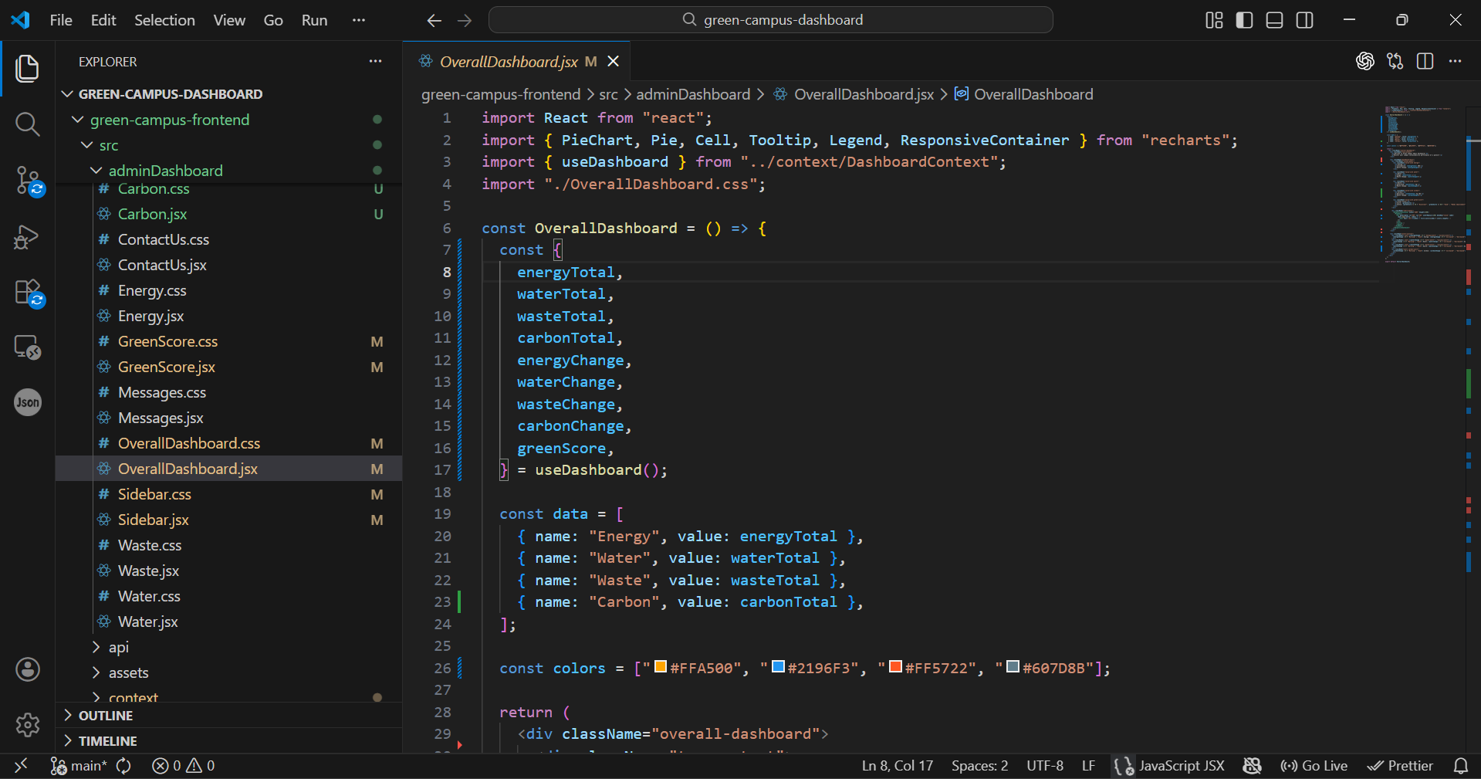

Figure 1 Frontend Interface

- BACKEND IMPLEMENTATION
This appendix presents the backend implementation developed using Python.
It handles data processing, API integration, and communication with the database.
The backend ensures efficient data management and system functionality.
It also supports features like data comparison, alerts, and Green Score calculation.

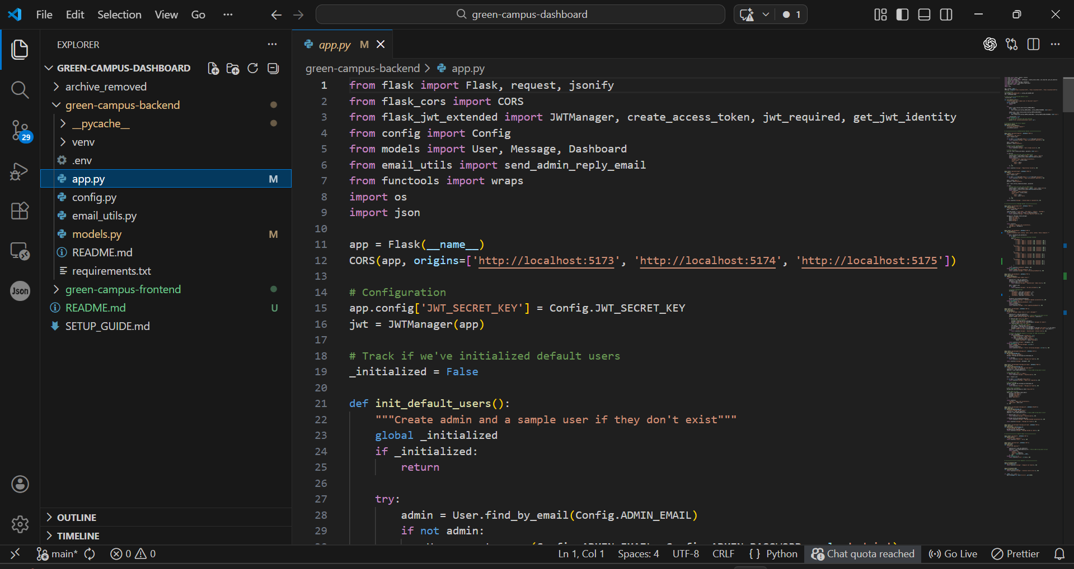
Figure 2 Backend Implementation

- OVERALL DASHBOARD
This appendix displays the overall dashboard of the system.
It shows key environmental parameters such as energy, water, waste, and carbon.
The dashboard includes visual elements like cards and pie charts for better understanding.
It provides a complete overview of campus sustainability performance.

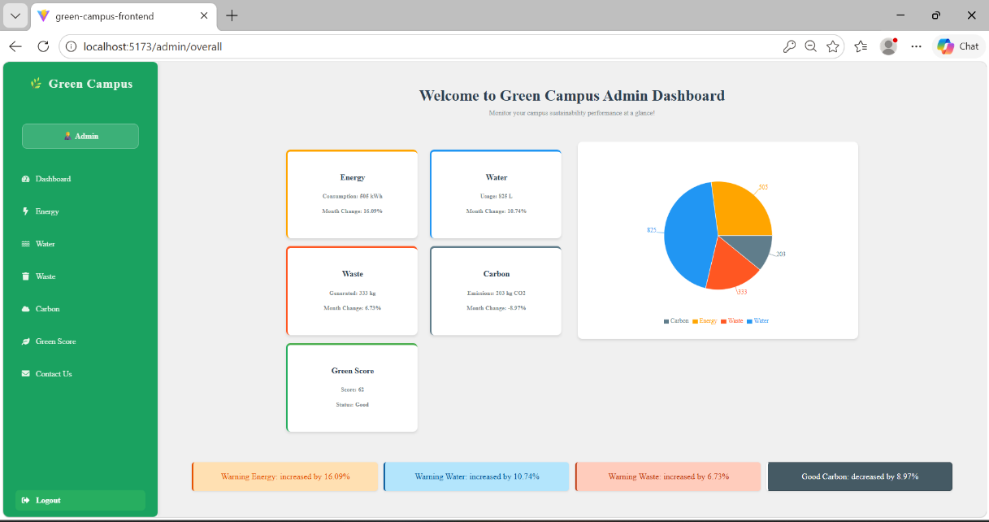

Figure 3 Overall Dashboard

- ENERGY DASHBOARD
This appendix shows the energy monitoring dashboard of the system.
It presents weekly energy usage data using bar graphs.
The dashboard allows comparison with previous month values.
It helps in analyzing and optimizing energy consumption.

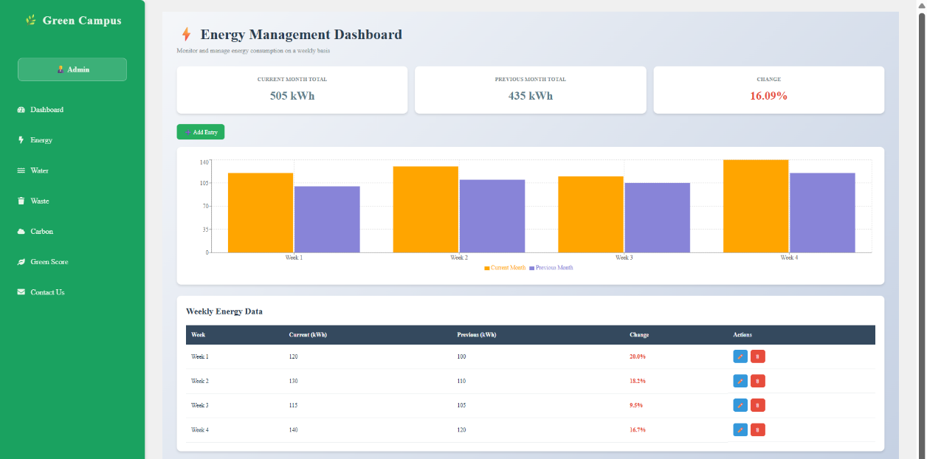
Figure 4 Energy Dashboard

- WATER DASHBOARD
This appendix presents the water usage dashboard.
It displays weekly water consumption data in graphical format.
The dashboard helps in identifying variations and usage patterns.
It supports efficient water resource management.

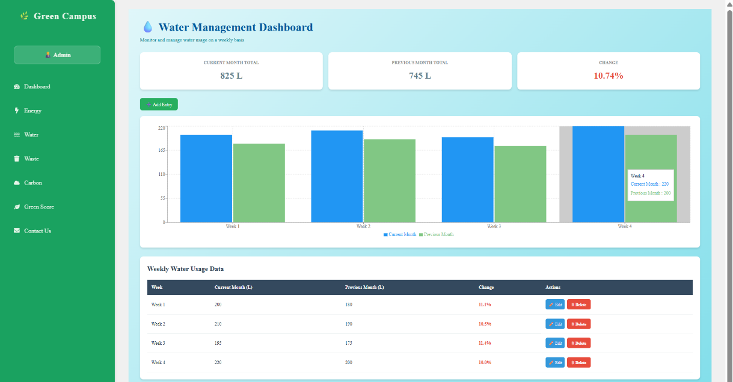
Figure 5 Water Dashboard

